**Meeting Minutes**

**Date: 11-Sep-2023 Time:** 1:25PM-1:40PM

**Project Title: ShopNexus**

**Members:**

|  |  |  |
| --- | --- | --- |
| **Registration No** | **Name** | **Attendance/ Remark** |
| 2021-CS-4 | M. Kabir Ahmad | **P** |
| 2021-CS-207 | Umair Noor | **P** |

**Type of Meeting: Physical**

**Location: Department of Computer Science Lab-03 , UET, Lahore.**

**Agenda:**

* **Requirement Gathering**

**Discussion:**

In our discussion, we set our project requirements which are as follow:

1. Admin will add, edit and remove Admins, Staff.
2. Admin will approve seller’s account and disapprove
3. Admin see products added by a particular seller and remove it from the store
4. Buyer will have shopping cart management
5. Profile Management
6. Secure Payment Processing
7. Order a product
8. Product Recommendation to customers
9. Order confirmation and cancellation
10. Customer Support
11. Push notifications
12. Product return and refund handlings
13. Product reviews and ratings
14. Product listing
15. Chat with sellers
16. Seller will maintain products
17. Seller can see reviews added by customers
18. Seller will confirm when he/she will hand over the order to the delivery man which will be forwarded to buyer.

**Signature:**

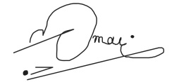

Owner

(Umair Noor)

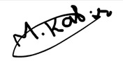

Developer

(Muhammad Kabir Ahmad)